Informe Avance/Final
“Sistema Inteligente de Gestión del Entrenamiento Canino para el SAG”
Inglés

Equipo 2

Docente
Mallén González González

Equipo alumnos
Javier Huaiquicheo Silva
Guiselle Montes Rojas
Susana Lapeyre Saldías

Duoc UC Sede San Bernardo
Escuela de Informática y Telecomunicaciones

San Bernardo, 13 de noviembre de 2025

Content table
Abstract 2
Issue 3
Solution 3
Project justification 3
Work hypothesis 4
Objectives 4
Methodology 4
XP values applied to the project 5
Evidences of project completion 6
Roles and project team 6
Project chronogram 7
Milestone 1: Requirement gathering and documentation 8
User Stories (HU) 8
Milestone 2: Design and model 12
Wireframes design 12
Mockup design 14
Milestone 3: First functionalities 18
Iteración 1 y 2 20
Participating entities 20
Project contribution in relation to professional interests 20
Group reflection 20
Individual reflections: 21
Profile skills 21
Conclusions 21
Bibliographic references 23
Annexes and appendices 23
a. Evidences 23

Abstract
The current project focuses on solving an important need from the Agricultural and Livestock Service of Chile (SAG) of modernizing their current management of canine training, due to the fact that they face diverse challenges caused by manual procedures and physical records.
The developed solution consists of the creation of an integral, secure and scalable web platform designed to centralize administrative procedures and key operatives. The work was executed with an agile methodology of Extreme Programming (XP), prioritizing continuous delivery, constant communication and the continuous improvement of code development to ensure its quality.
As a result, a functional minimum viable product (MVP) was developed, which includes modules for the management of users, training records, and report generation.

Issue
The Agricultural and Livestock Service managed the training of their canines using physical records and tools that were not specialized. This focus generated the loss of information and inefficiencies in the tracking of canines during their training, making it difficult to evaluate the individual progress of each canine, which interfered in decision making, increasing the risk in the tracking of training records.

Solution
A responsive and secure web platform was developed with a NextJS frontend, Django backend, and a PostgreSQL database, which centralizes all the operations of canine training. This solution allows the trainers to record training sessions, track errors, and evaluate the individual performance of each canine, and generate reports to allow for better decision making, guaranteeing complete traceability of the training history. The development was done using the agile methodology of XP, which allowed continuous shipment to incorporate constant feedback to ensure high quality code.

Project justification
Currently, while diverse digital platforms exist that allow the tracking and management of canines, these do not adjust or accomplish in their totality the specific needs of the canine operative training. It is why, during the development this platform seeks to centralize and digitalize the training process, allowing the possibility to record progress evaluate the performance and facilitate the decision-making process in a single place, using an intuitive, accessible and secure interface.

Work hypothesis
Doesn’t apply.

Objectives
General objective of our project
Design and develop “Intelligent training management system of canines for SAG”, allowing registration and tracking of SAG’s canines during their training.
Specific objectives:
- Desarrollar un MVP del proyecto que obtenga la aprobación de los usuarios claves.
- Gather requirements using User Stories (HU) to determine the system’s functionalities.
- Design the canine registration profile to allow their tracking during training, so that the trainers can verify their progress alongside their trajectory.
- Design the canine registration profile so that trainers can input, update, and read the canine’s information.
- Design a view that allow easy visualization of the canine’s progress.
- Design and develop the system guaranteeing accessibility, usability and responsive design to adapt to any device.
- Develop an MVP of the project that obtains the approval of key users.

Methodology
For the development of our APT project, we chose the agile Extreme Programming methodology (XP), which focuses on producing quality software and seeks client satisfaction. According to Raeburn (2025), Extreme Programming is an agile methodology of project management which focuses on speed, simplicity, short development cycles, and less documentation.
During the first phase, we did a starting investigation of the project, studying our client with secondary information. We defined the reach, general objectives and specifics, and other important aspects of our project. An interview with the client was also conducted with the purpose of defining the project’s requirements, and the necessary tools for the development of the project were configured.
In the next phase, Wireframes and Mockups of the website were developed, also, the User Stories were defined, and the first functionalities of the website were developed. An ER model was designed. Iterations during these phases were 1 to 3 weeks long.
The reason why we chose this methodology was to accomplish our objectives during the time perior that was granted to us of approximately 3 months, for which we needed way to work that prioritized the delivery of results in little time and allowed us to adapt to changes because of its flexibility.

XP values applied to the project
During the development of the project, our team adopted the following values of XP, which guided us in collaboration and the delivery of value:
- Communication: The team kept communication with SAG’s representatives, sharing advances, solving doubts, and ensuring that the requirements were fully understood. This allowed each iteration to adapt to the real needs of our client.
- Simplicity: The development of simple and functional solutions was prioritized, focusing on delivering an MVP that meets the basic needs of canine training before adding additional functionalities.
- Feedback: Each iteration was reviewed by the team, allowing rapid adjustments in the User Stories, wireframes, mockups and developed functionalities, ensuring that the product was adjusted to the SAG’s requirements.
- Respect: Each team member was valued and respected mutually, recognizing abilities, time and each member’s opinions, which facilitates a collaborative effort and efficient distribution of tasks.

Evidences of project completion

Roles and project team
The teams' roles were assigned in the following manner. Since we were a small team of 3 people, some roles were shared, which allowed the whole team to participate, both in development and documentation of the system.

Rol | Nombre | Descripción
Team leader, developer, documentation. | Javier Huaiquicheo Silva | Responsible for general coordination of the project, development of the backend, frontend, and database, helping the development of technical documentation and responsible for the management and control of the GitHub repository.
Developer, documentation and coach. | Guiselle Montes Rojas | Responsible for general documentation, XP and front-end development with NextJS, coach of the right application of principles and XP practices.
Developer, documentation and tracker. | Susana Lapeyre Saldías | Responsible for general documentation, XP and front-end development with NextJS, tracker of the project, and responsible for the chronogram and tracking of tasks and deliveries.
Client representative. | José Luis Villablanca | Responsible for reviewing project development, giving feedback, and ensuring that the development goes according to planned.
Client representative. | Mallén Gonzales | Responsible for reviewing and guiding the project development from the client’s perspective, reviewing deliverables, and taking part in meetings being the client’s representative.
Table 1: Roles and project team (Own elaboration)

Project chronogram
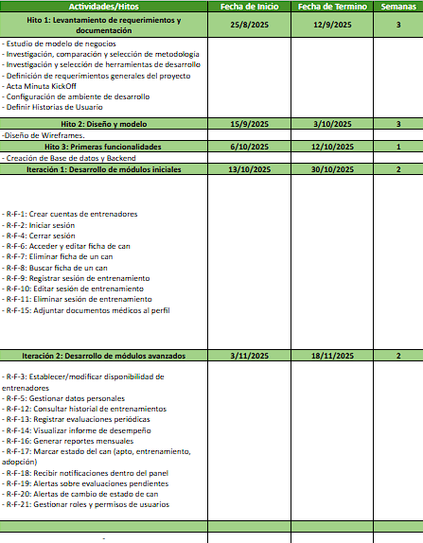
Image 1: Project chronogram (Own elaboration)

Milestone 1: Requirement gathering and documentation
In the first milestone the business model was studied, an investigation was done, comparison and methodology selection, and the choosing of tools for the project development, general requirements were defined following meetings with the client using User Stories, and the meeting minutes kick off was done, finally the development environment was developed.

User Stories (HU)
The user stories were obtained after interviews and delivery of documentation by the client representative, José Luis Villablanca.
User Story: R-F-1
As | Admin
Want | Create trainer accounts in the system
For | So that trainers can access the system and register info to the system.
Table 2: HU. (Own elaboration)

User Story: R-F-2
As | Trainer
Want | Login with credentials
For | Acess basic training fuctions and observations.
Table 3: HU. (Own elaboration)

User Story: R-F-3
As | Admin
Want | Establish and modify various disponibility states of a trainer
For | To manage workloads and free resources/licenses if needed and keep precise visibility of the team’s availability.
Table 4: HU. (Own elaboration)

User Story: R-F-4
As | Trainer
Want | Finish own session in the system
For | Keep security of my account.
Table 5: HU. (Own elaboration)

User Story: R-F-5
As | Trainer
Want | Manage my personal data
For | Keep my account info updated.
Table 6: HU. (Own elaboration)

User Story: R-F-6
As | Trainer
Want | Access and edit a canine file.
For | Keep it updated with info on tracking and observations.
Table 7: HU. (Own elaboration)

User Story: R-F-7
As | Admin
Want | Delete a canine’s file.
For | Retire from the system the canines that no longer take part in the program.
Table 8: HU. (Own elaboration)

User Story: R-F-8
As | Trainer
Want | Search a canine’s file by name.
For | Quickly find a canine in the system.
Table 9: HU. (Own elaboration)

User Story: R-F-9
As | Trainer
Want | Register a training session including success points and observations.
For | Track objective progress and performance.
Table 10: HU. (Own elaboration)

User Story: R-F-10
As | Trainer
Want | Edit a training session
For | Correct or update information.
Table 11: HU. (Own elaboration)

User Story: R-F-11
As | Trainer
Want | Delete a training session
For | Delete incorrect records or duplicates.
Table 12: HU. (Own elaboration)

User Story: R-F-12
As | Usuario
Want | Read the complete history of training of each canine.
For | Evaluate their performance.
Table 13: HU. (Own elaboration)

User Story: R-F-13
As | Trainer
Want | Register periodic evaluations of a canine's performance.
For | To measure progress in their abilities.
Table 14: HU. (Own elaboration)

User Story: R-F-14
As | Usuario
Want | Visualize a performance report of a canine.
For | Analize if the canine accomplishes the standards defined by SAG.
Table 15: HU. (Own elaboration)

User Story: R-F-15
As | Trainer
Want | Attach medical documents to a canine’s profile.
For | Backup their health status.
Table 16: HU. (Own elaboration)

User Story: R-F-16
As | Admin
Want | Generate monthly reports of all canines.
For | Keep global control of the program.
Table 17: HU. (Own elaboration)

User Story: R-F-17
As | Trainer
Want | Mark a canine as “suitable for service” on training or “suitable for adoption”
For | Reflect their status and facilitatle decision making over ther continuity.
Table 18: HU. (Own elaboration)

User Story: R-F-18
As | Usuario
Want | Receive notifications within the app’s panel.
For | Keep track of events.
Table 19: HU. (Own elaboration)

User Story: R-F-19
As | Admin
Want | Receive alerts when a can has pending evaluations.
For | Ensure the plan is completed.
Table 20: HU. (Own elaboration)

User Story: R-F-20
As | Trainer
Want | Receive alerts when a canine changes status.
For | Adjust during training as needed.
Table 21: HU. (Own elaboration)

User Story: R-F-21
As | Admin
Want | Manage roles and user permissions.
For | Ensure each profile only has access to what’s needed.
Table 22: HU. (Own elaboration)

Milestone 2: Design and model
In this milestone Mockups and Wireframes were designed, alongside an ER model for the database to start with the firsts iterations and system development.

Wireframes design
First designs with wireframes, in charge of the basic structure of the system in a low and medium fidelity.
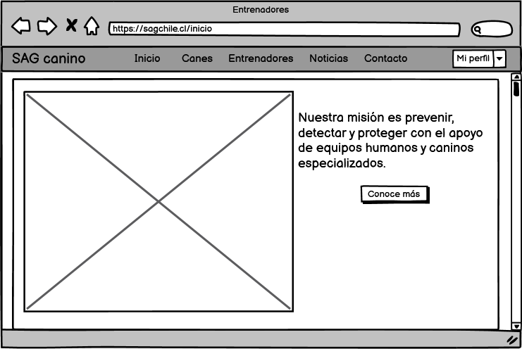
Image 2: View Landing page. (Own elaboration)
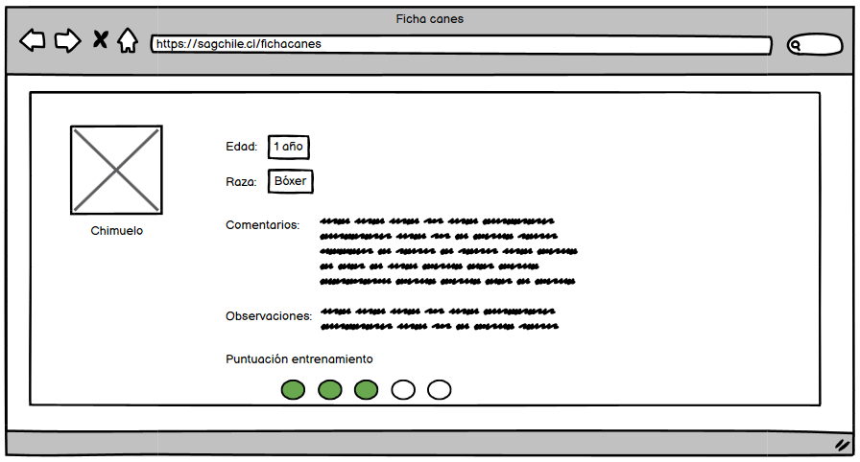
Image 3: Individual can file. (Own elaboration)
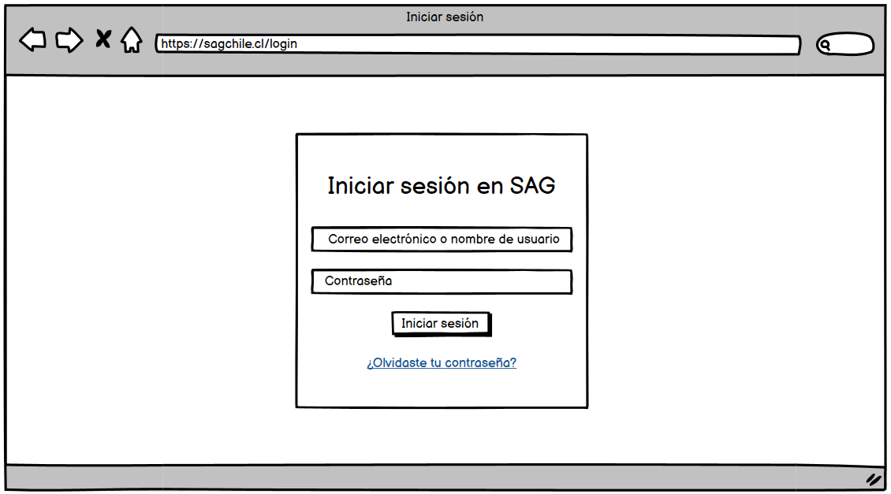
Image 4: Login. (Own elaboration)

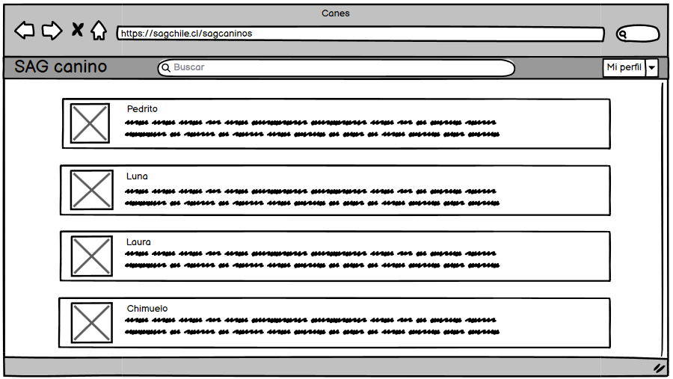
Image 5: View of canine file lists. (Own elaboration)

Mockup design
This time, Mockups were designed with a focus on a medium to high fidelity, colors were chosen for the system focusing on the institutional colors of SAG.
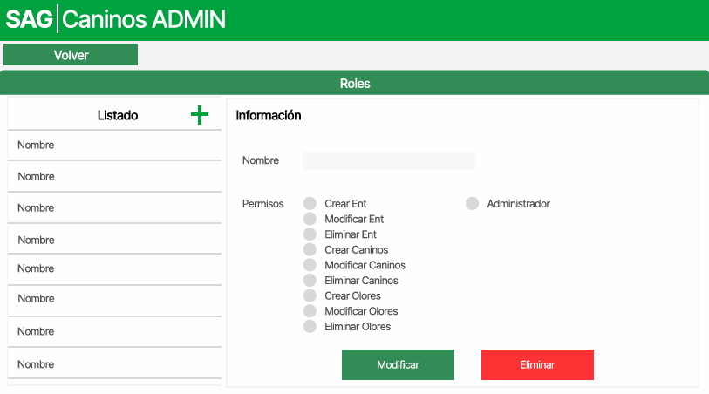
Image 6: View Admin. (Own elaboration)
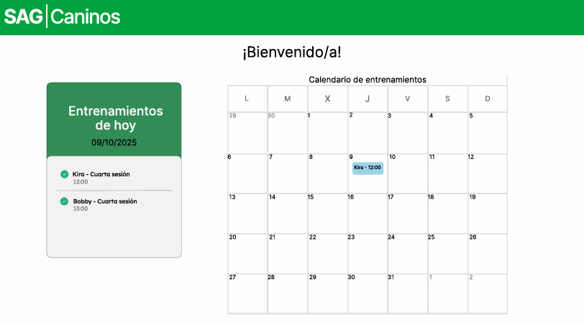
Image 7: View Landing page. (Own elaboration)
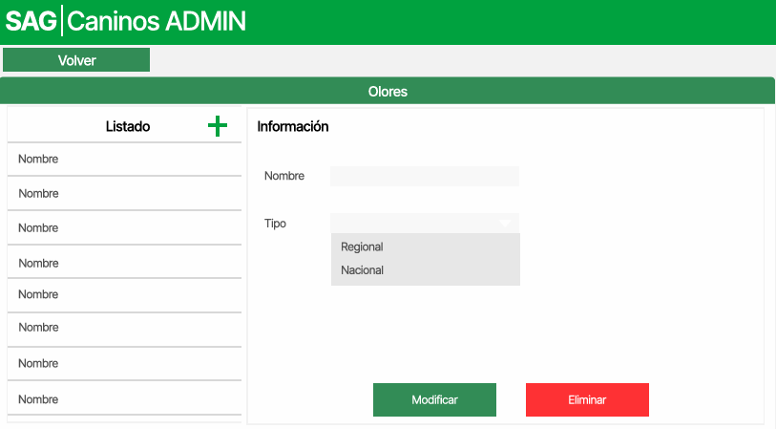
Image 8: View Admin. (Own elaboration).
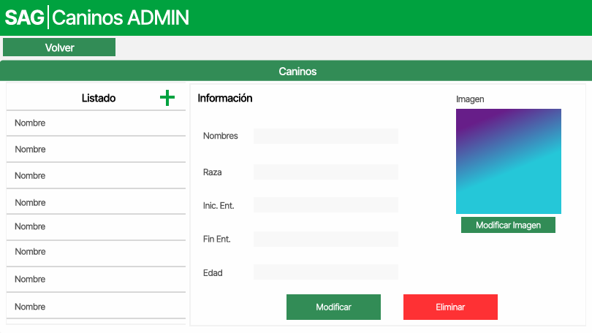
Image 9: View Admin. (Own elaboration)
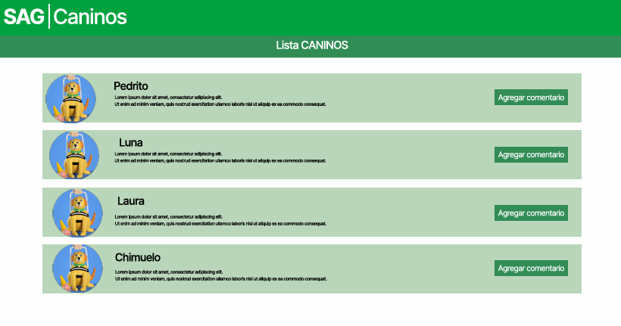
Image 10: View canine list. (Own elaboration)
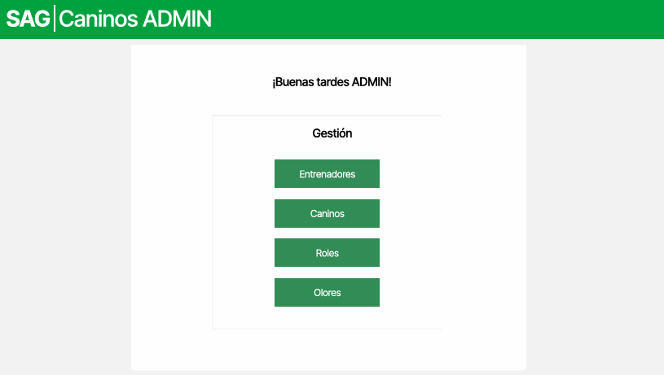
Image 11: View user management. (Own elaboration)
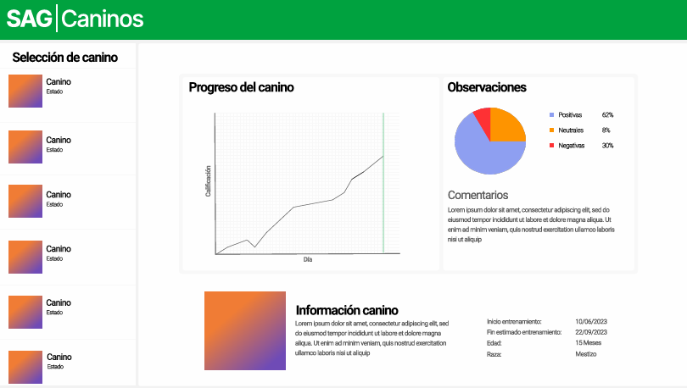
Image 12: View canine files and Dashboard. (Own elaboration).

Milestone 3: First functionalities
In this stage, the first functions of the website were developed, with the creation of the database and the backend with Django and PostgreSQL, and the development of the frontend with NextJS. On this first iteration, the landing page of the site was made.
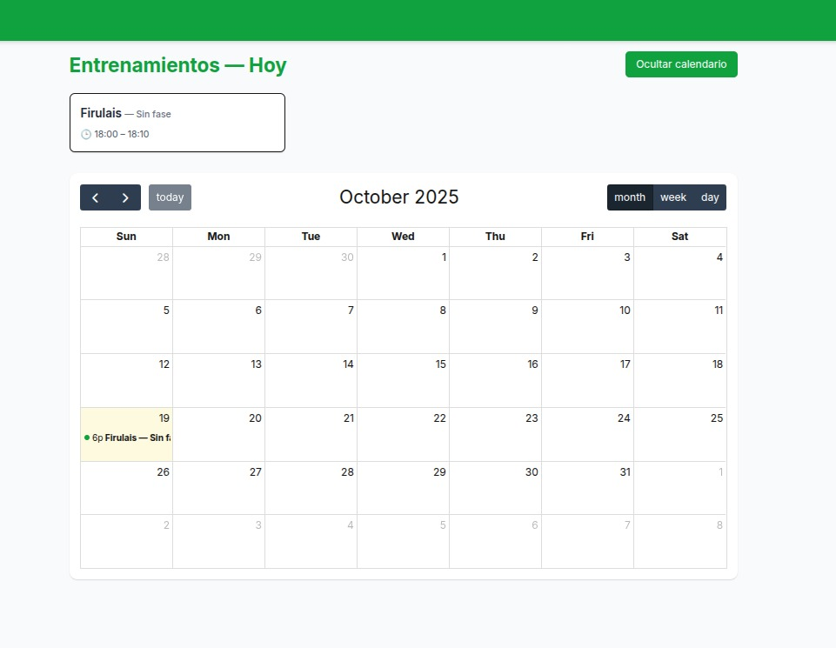
Image 13: Landing page development from first iteration. (Own elaboration)

Reach and impact / Enviroment link
The web platform for the agricultural and livestock service focuses on generating specific and strategic high impact on the supervising function, beneficiating the following groups:
- Canine unit trainers: The project’s impact is reflected on the efficiency and quality of the training process. The platform allows the structured registration of comments and observations post training, crucial for traceability and performance review, it also counts with assignation management of canines for each trainer, facilitating the supervision and planning of the detection animals.
- SAG as an institution strengthens its capacity for inspection and animal/plant health by ensuring that its canine detection force operates with the highest standards of efficiency and record-keeping.
- Producers and citizens: The benefit is indirect, but it is fundamental because faster, more accurate and efficient inspection, facilitated by highly trained dogs, protects national agricultural health, allowing Chilean exports to maintain their international prestige.

Iteration 1 y 2
Image 14: Login. (Own elaboration).

Image 15: Landing page. (Own elaboration).

Image 16: Canine list. (Own elaboration).

Image 17: Canine file. (Own elaboration).

Image 18: Dashboard. (Own elaboration).

Image 19: Training session management. (Own elaboration).

Image 20: Admin panel. (Own elaboration).

Participating entities
Agricultural and Livestock Service (SAG): It’s a government organization from Chile which purpose is the development of agriculture and livestock of the country, this entity is the client who the project is being developed for.

Duoc UC: It’s the professional institute which does the intermediary role between the students in charge of the development of the project and the client, they’re in charge of providing the students everything they need for the successful development of the project, including support from professors, area managers and bibliographic support.

Project contribution in relation to professional interests
This project represents a significant and educational opportunity to put into practice the technical knowledge acquired during our academic training, with a high-impact, real-world case. The development of this web platform was key to consolidating our skills and achieving our professional goals.
For the team it was key:
- Applying agile methodologies in an environment with defined and rigorous requisites.
- Developing skills in full stack with modern technologies.
- Strengthening bland skills like communication, teamwork, time management, and adaptability.
- Understanding the importance of usability and security in systems geared towards non-technical users.

Group reflection
During the project development the team faced challenges like the equivalent distribution of work in a remote enviroment, the management of the client's expectations and a learning curve on new technologies. Nonetheless, the rigorous application of XP, like constant communication and mutual respect, allowed us to overcome these obstacles and deliver a product aligned with the needs of SAG.

Individual reflections:
- Javier Huaiquicheo Silva: Throughout the project, I learned to effectively develop a backend, frontend, and database. In addition to setting up a development environment managed by Docker and Github, I was able to effectively express my development intentions to my team and efficiently achieve my personally set goals within the project. Despite encountering complications that interfered with its development, I persevered, putting in the necessary effort for its success.
- Susana Lapeyre Saldias: In this project, I learned to face various obstacles and challenges, such as time management, group communication, learning tools I wasn't familiar with like Docker and Next.js, and learning and applying a new methodology to a project: Extreme Programming (XP). I developed the project plan and documentation, as well as documentation for the XP methodology, and I also handled front-end development. As I mentioned before, there were some obstacles I had to overcome to move forward with the project. There's still a long way to go, but this experience has helped me better understand my weaknesses and strengths, and having this opportunity will help me grow and improve both professionally and personally.
- Guiselle Montes Rojas: During this project, I learned to communicate more effectively with my team, expressing my ideas clearly and actively listening to others' opinions. I also developed a more proactive attitude, actively participating in tasks and seeking solutions when difficulties arose. Furthermore, I strengthened my sense of responsibility, meeting commitments and deadlines. These experiences helped me grow both personally and professionally, improving my teamwork skills and my commitment to the group's objectives.

Profile skills
- Development of technological solutions with an agile focus and centralized on the user.
- Capacity for teamwork on multidisciplinary teams.
- Efficient management of projects under agile methodologies.
- Effective communication with non-technical interested parties.
- Appliance of good practices in quality, security, and maintainability.

Conclusions
The development of the Intelligent Canine Training Management System for SAG allows us to address the need to optimize and streamline the management and monitoring of their canines training through a minimum viable product (MVP). This system centralizes and organizes information and tracks each dog individually, enabling better training decisions.

This project represents another step in SAG's technological modernization, allowing them to digitize their processes for more effective decision-making and improving the quality of canine training and trainer productivity.

Bibliographic references

Raeburn, A. (2025, febrero 13). ¿Qué es la programación extrema (XP)? (2025) Asana. Asana. https://asana.com/es/resources/extreme-programming-xp

Annexes and appendices

Evidences
We have currently developed designs and diagrams that will aid in the project's development. We began with wireframes, which we transformed into mockups to give us a better visualization of the project's front-end. In addition, we developed the database that we used for the project, as well as its models applied within the system, meeting the client's needs.

The evidences developed so far in our project includes the following:
- Acta Minuta Kick Off: Acta Minuta Kick Off
- Acta de Constitución: Acta de Constitución
- Wireframes: Wireframes
- Mockups: Mockups
- Diagrama de BDD: Diagrama BDD SAG V2.png
- Evidencias del sistema y desarrollo: Evidencias de desarrollo
- Historias de usuario: Historias de Usuario
- Cronograma proyecto: Cronograma
- Tarjetas CRC: Tarjetas CRC
- Repositorios de GitHub: Repositorio Proyecto / Repositorio documentación

